**PROJECT TITLE**:**Enhancing Road Safety with AI-Driven Traffic Accident Analysis and Prediction**

**PHASE 2**

**STUDENT NAME : THIRUMALAI G**

**REGISTER NUMBER:620523243057**

**INSTITUTION :CMS COLLEGE OF**

**ENGINEERING,**

**NAMAKKAL.637003**

**DEPARTMENT :B.TECH- ARTIFICIAL**

**INTELLIGENCE AND**

**DATA SCIENCE**

**DATE OF SUBMISSION:**

**GITHUB REPOSITORY**

**LINK :**

**1.Problem Statement:**

Road traffic accidents are a significant cause of death and injury worldwide. Predicting and

analyzing these incidents using AI can help authorities take proactive steps to reduce their

frequency and severity.

**2.Project Objectives:**

- Analyze historical traffic accident data.

- Identify contributing factors and trends.

- Develop a predictive model to forecast accident likelihood.

- Visualize insights for better decision-making.

**3.Flowchart of the Project Workflow:**

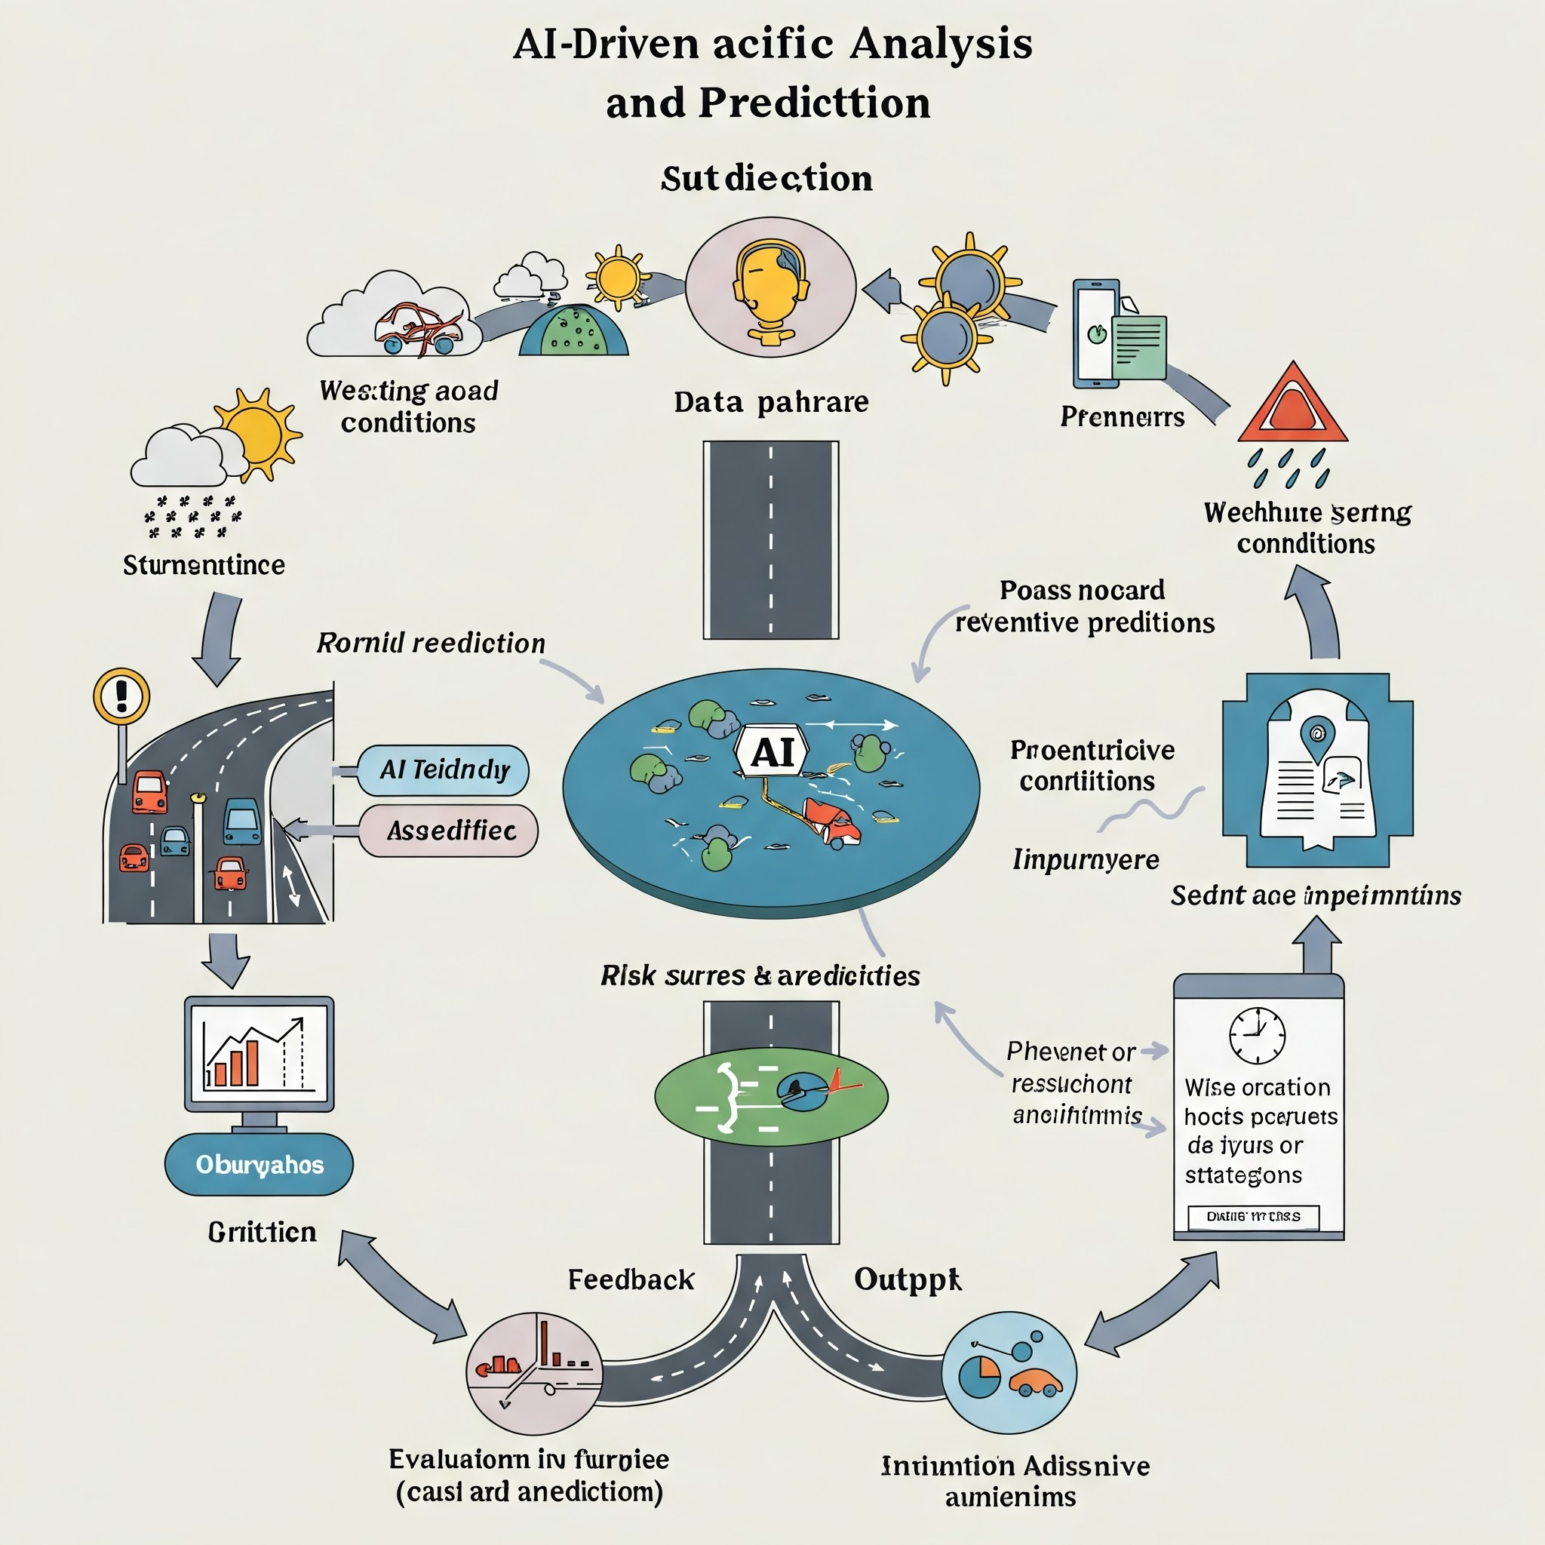

**4.Data Description:**

- Date & time of accident

- Location (longitude, latitude)

- Weather conditions

- Road conditions

- Severity levels

- Vehicle and pedestrian involvement

**5.Data Preprocessing:**

- Handling missing values

- Encoding categorical variables

- Normalization/Standardization

- Outlier detection and removal

**6.Exploratory Data Analysis (EDA):**

- Accident trends over time

- Heatmaps of high-incident zones

- Impact of weather and road conditions

- Severity distribution by region

**7.Feature Engineering:**

- Time-based features (e.g., rush hour)

- Aggregated area-level risk scores

- Severity score scaling

- Derived interaction terms

**8.Model Building:**

- Algorithms used: Random Forest, XGBoost, Logistic Regression

- Evaluation metrics: Accuracy, Precision, Recall, ROC-AUC

- Hyperparameter tuning

- Cross-validation results

**9.Visualization of Results & Model Insights:**

- Confusion matrix

- Feature importance graphs

- Geographic accident risk maps

- Trendline forecasts

**10.Tools and Technologies Used:**

- Python (Pandas, NumPy, Scikit-learn, XGBoost)

- Jupyter Notebook

- Tableau / Matplotlib / Seaborn

- GitHub for collaboration

- Google Colab

**11.Team Members and Contributions:**

- Member A Data collection, preprocessing

- Member B EDA and visualization

- Member C Model building and evaluation

- Member D Documentation and presentation